Subject : ENGLISH LANGUAGE
Class : 7. ( THE SEVENTH )
Exercise : OVERWEIGHT

Read the following text :

OVERWEIGHT
The overweight is very serious and chronic disease of modern world. It could caused a lot of medical complication such as: stroke, high blood pressure, heart attack or heart failure, kidney failure. To avoid these complications, it is necessary to learn to make correct relation to food and eating habits from the earliest period of life.

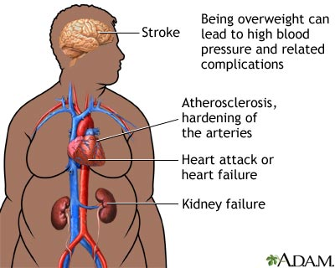

Less 1.
TRUE OR FALSE (circle the right state):

1. The overweight could caused high blood pressure. T F
2. The overweight is not disease of modern world. T F
Less 2.
ANSWER THE QUESTION
1. What is the overweight?
2. What could the overweight caused to man?
3. How can we avoid the disease caused by overweight?
1. ______________________________________________________________________
2. ______________________________________________________________________
3. ______________________________________________________________________
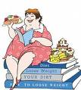

Исходи који се остварују :
- примена знања енглеског језика и разумевање прочитаног текста
- развијање радозналости и истраживачког духа помоћу текста о поремећајима изазваним неправилним начином исхране ( текст везан за највеће здравствене проблеме 21. века )

